ER Diagram
Draw an ER diagram accordingly to the following user requirements. You can draw the diagram using tools that you prefer, such as Microsoft Viso, which is available in most of the ECS labs. Turn in PDF file.

A database is gathering the following information:
- Doctors are identified by their SSNs. For each doctor, the name, specialty must be recorded.
  - 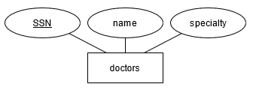
- Each pharmaceutical company is identified by a unique name and has a phone number.
  - 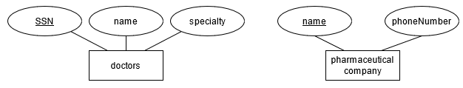
- For each drug, the trade name and formula must be recorded. Each drug is manufactured by a pharmaceutical company, and the trade name identifies a drug uniquely from among the products of that company. If a pharmaceutical company is deleted, you need not keep track of its products any longer.
  - 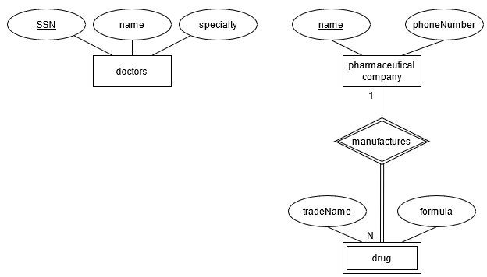
- Each pharmacy has a unique name, address and phone number. Each pharmacy sells several drugs and has a price for each. A drug could be sold at several pharmacies, and the price could vary from one pharmacy to another.
  - 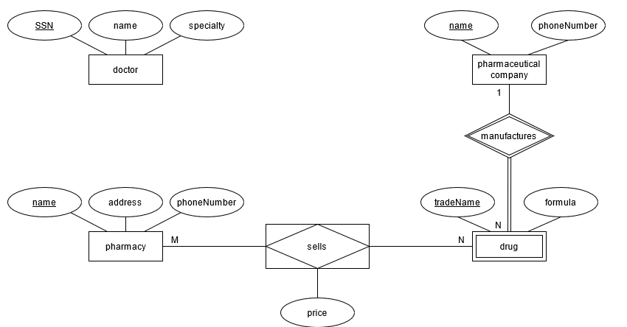
- Doctors can make many prescriptions. Each prescription has a unique number with regard to a doctor. The prescription date is also recorded. A prescription is made by one and only one doctor.
  - 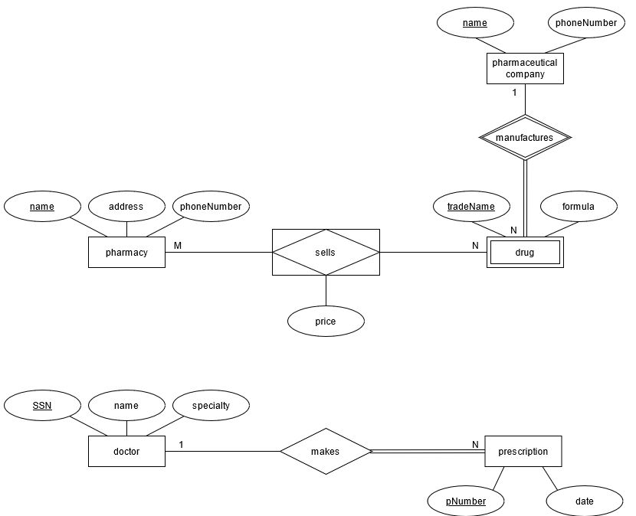
- Each prescription can include one or many drugs.
- One drug can be sold by many pharmacies and one pharmacy can sell many drugs. A drug may or may not be ordered from a pharmacy, as it can also be bought on the internet.
- One drug can be made by one pharmaceutical company where as a pharmaceutical company can make many drugs.
  - 